- Though GDP surprised on the upside in November, this is unlikely to mark a turning point for the UK economy. Much of November's strength was payback for earlier weakness, while evidence of residual seasonality in the GDP data continues to build. Continued private sector weakness is likely to mean that 2026 is another challenging year for the UK economy.
- The 10-year gilt yield dropped to a 13-month low ahead of the GDP release. This largely reflects lower market expectations for Bank Rate, with pricing falling into line with our forecast of two 25bp cuts this year. We think bond yields are unlikely to fall much further in the near term due to structurally higher term premia.
Good news on economic growth has been in short supply of late, with official data reporting a prolonged soft patch after a strong start to last year. But this week's GDP release for November provided a rare upside surprise, with output reported to have risen by 0.3% m/m.
However, delving into the detail, a decent chunk of November's strength appears to be payback for earlier weakness. In several parts of the services sector – most notably professional services, information and communications, and distribution – output was reported to have fallen sharply in October but then recovered strongly in November. This appears to be noisy data rather than there being any strong underlying narrative.
But there's a clearer story in the rebound in manufacturing output. A major motor manufacturer halted production at the end of August in response to a cyber-attack, which had significant knock-on effects along the automotive supply chain. Production restarted in October and was gradually ramped up, such that in November, output was only just short of its August level.
One concern that we've regularly raised over the past couple of years is the likely existence of residual seasonality in the GDP data. Strong starts to each year have tended to peter out, before a rally towards the end of the year. The November outturn kept the 2025 GDP data closely tracking the month-by-month profiles of 2022 and 2024, reinforcing our concerns about this issue (Chart 1).
Chart 1: The 2025 GDP data continue to track the seasonal pattern of recent years
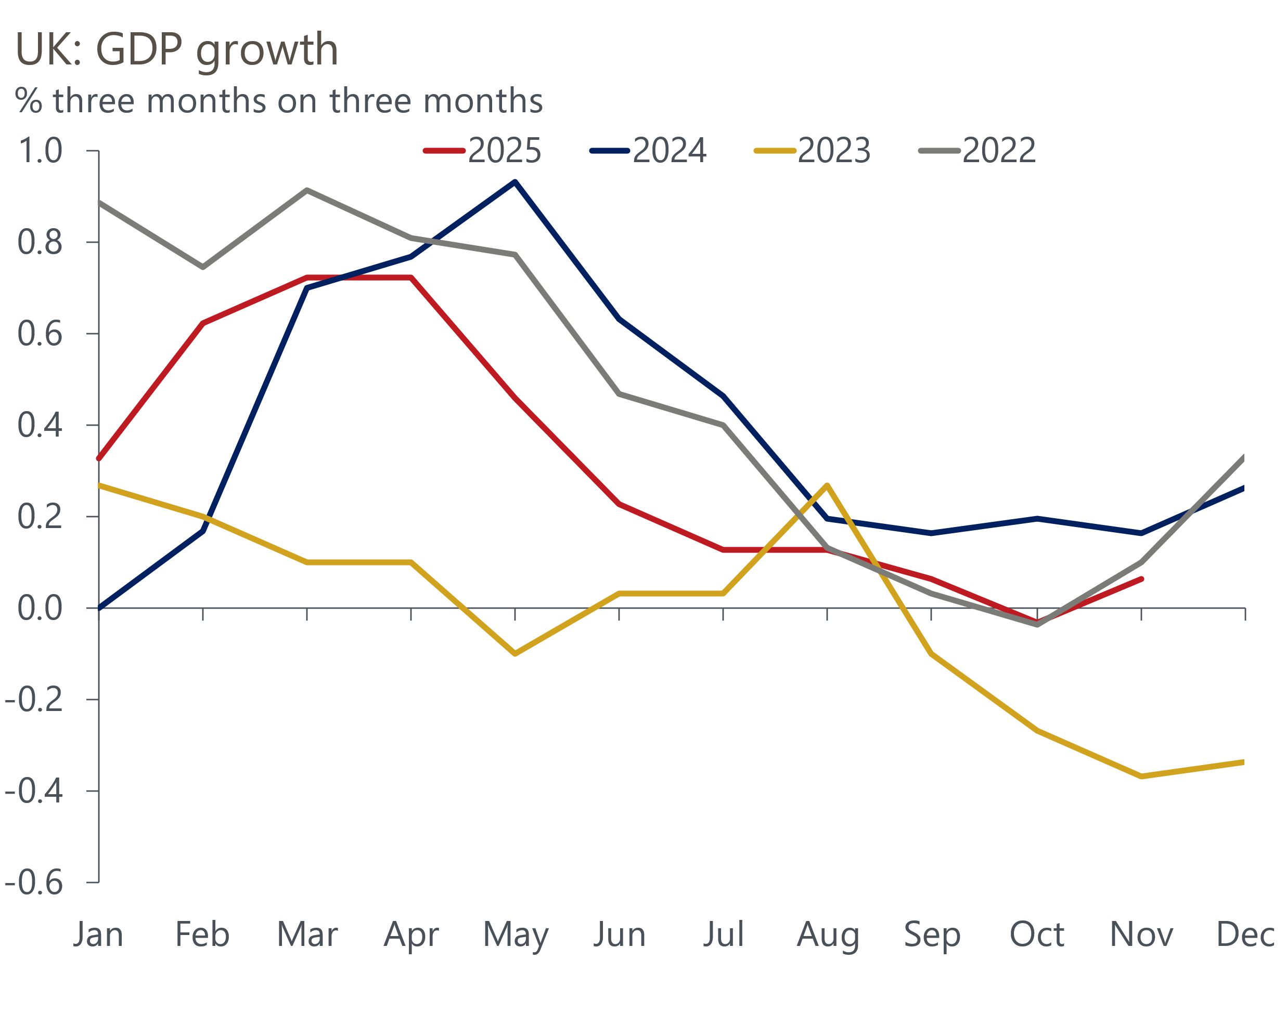
Source: Haver Analytics

On balance, we think it unlikely that November's upside surprise will mark the start of a change of fortunes for the UK economy. The ongoing problem with residual seasonality means it's perfectly possible that the monthly GDP data continues to strengthen around the turn of the year, and that growth in Q1 2026 is above trend. But even if that proves to be the case, we expect momentum to quickly fade, as in previous years. As we argued in last week's edition, there's little support for GDP growth outside of the public sector, and this picture is unlikely to change this year given the pressures on households and companies.
One consequence of the GDP release was that it arrested the fall in government bond yields. At market close on Wednesday, the 10-year yield had fallen to 4.34%, the lowest level since December 2024. Fiscal developments have been a relatively minor influence on bond yields – most of the 40bp fall in the 10-year yield since its early-October peak occurred before the Budget had taken place (Chart 2).
Chart 2: The fall in bond yields has occurred across the curve
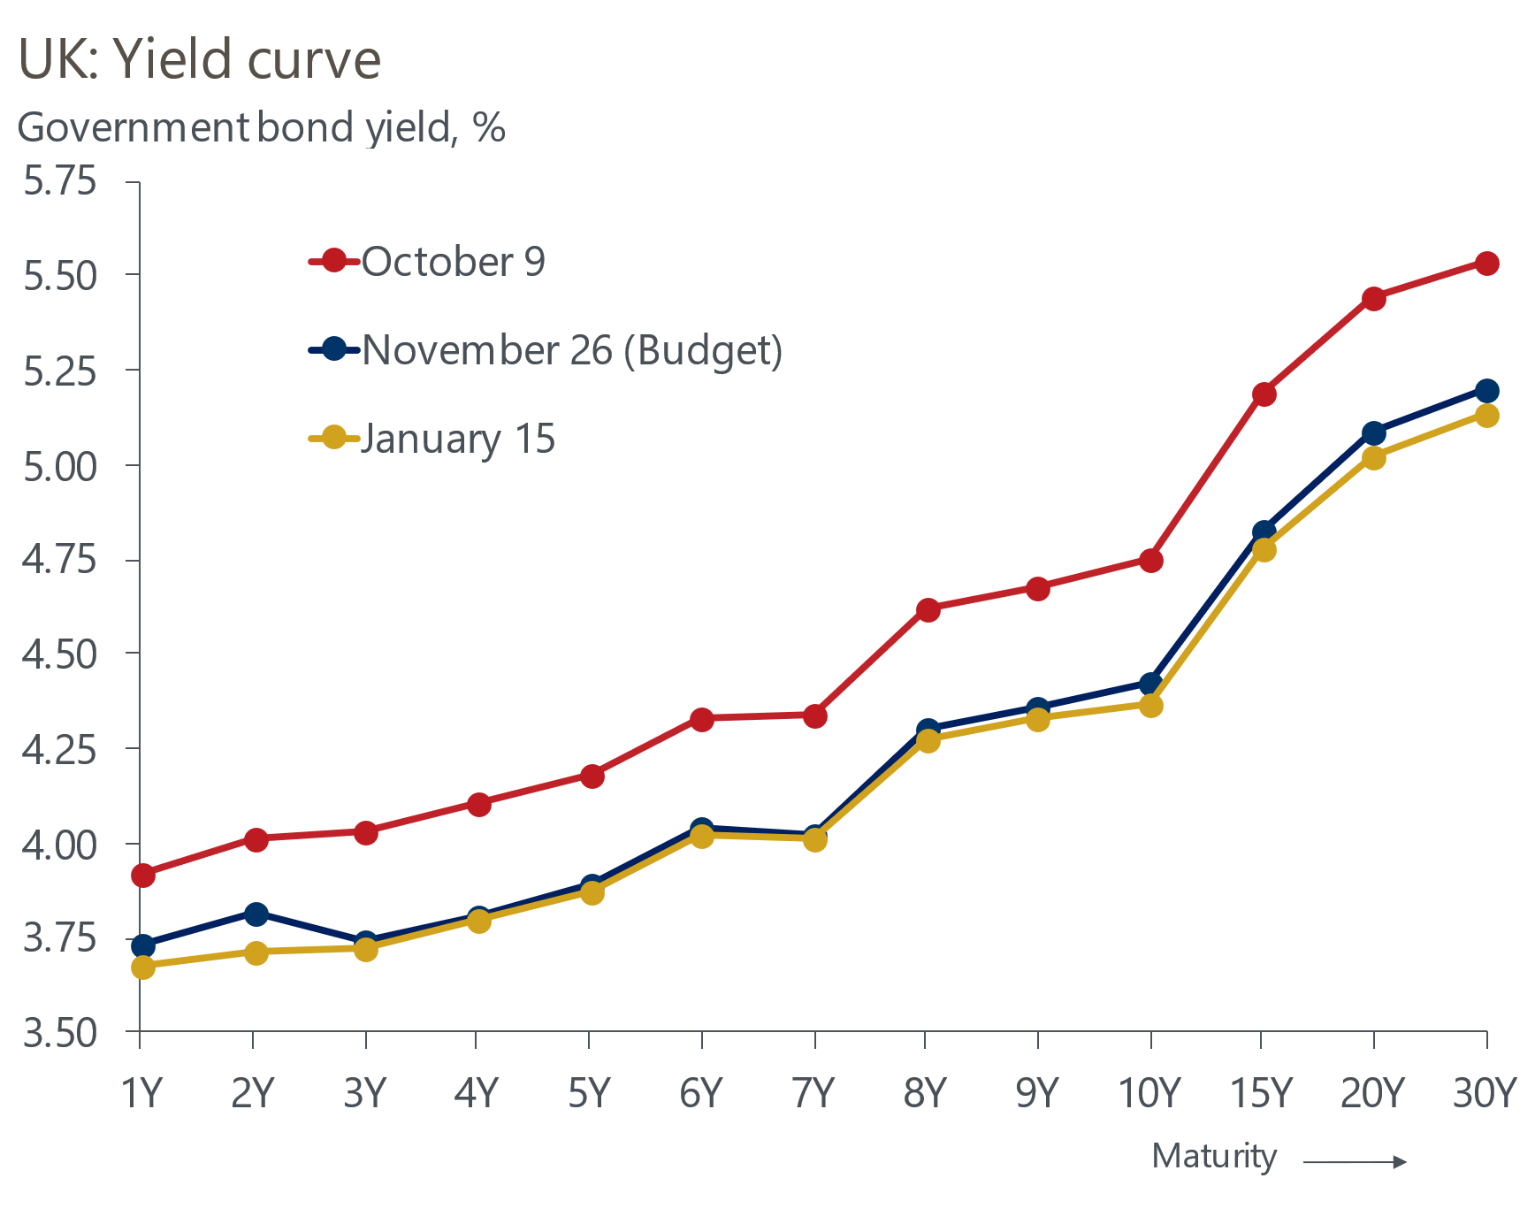
Source: Haver Analytics
Rather, lower market expectations for the path of Bank Rate appear to have been key. Yields have fallen across the curve, particularly in response to successive downside surprises for inflation, and markets now almost fully price two 25bp rate cuts this year.
This has brought market pricing into line with our forecast for Bank Rate. But as we argued in a recent note, structurally higher term premia is likely to continue to mitigate the downward pressure on bond yields. Several factors are likely to cause term premia to remain high.
The UK's poor fiscal position has resulted in markets being asked to digest very high levels of gilt issuance, and sales through the Bank of England's quantitative tightening programme is further adding to supply. This comes against a backdrop of sharply increasing global supply of highly rated government bonds.
On the other side of the ledger, structural changes in the pension sector are weakening demand. The pensions sector has been a large and relatively price-inelastic purchaser of gilts, particularly at the long end. But the emerging marginal buyer of gilts is flightier and more price-sensitive. This will force the Debt Management Office to continue to shift supply towards shorter maturities.
In this environment of abundant supply and weakening demand, it looks unlikely that gilt yields will continue to fall back. Furthermore, though the financial market response to the Budget has been muted, fiscal and political risks haven't gone away. The Chancellor's recent announcement of a relief package for pubs to mitigate the impact of the increase in business rates announced in the Budget adds to the impression that the government struggles to follow through with plans to tighten fiscal policy. This is just one of a number of problems we've identified with the government's fiscal approach. And though this week's media focus has been on turbulence at the top of the opposition Conservative party, serious questions remain over whether the leadership of the governing Labour party will be able to remain in post.
So while our baseline assumption is that the government finds a way to muddle through and keep a lid on yields, a scenario where markets suddenly take fright remains a live risk.

The week ahead
A busy week of official and business survey data begins with the labour market release for the September to November period. Pay growth has been drifting lower in recent months through a combination of strong base effects and faltering momentum. We expect this trend to have continued in November, with headline (three-month average of the annual rate) total pay growth set to slow to 4.6% and regular pay growth expected to slip to 4.4%. We expect the LFS measure of unemployment will hold steady at 5.1%.
Successive downside surprises saw CPI inflation drop to 3.2% in November. We think the downward momentum was temporarily halted in December. Some of November's downward pressure came from volatile categories, including clothing, air fares, and accommodation services, and this is likely to have unwound in December, although the choice of date for collecting the data will likely have a crucial bearing on the outturn for air fares. In addition, the later Budget caused a negative base effect in the tobacco category in November, but that should have reversed in December as the 2025 Budget uprating in tobacco duty came into effect. Overall, we think CPI inflation will come in at around 3.6% in December.
Retail sales fell for a second successive month in November, after four consecutive monthly rises before that. We think December probably saw an end to the recent weaker run. Successive large monthly falls in the food and non-store sectors took the level of sales well below where they were earlier in 2025, so we think there was scope for some payback. We pencil in a 0.2% m/m rise in sales in December.
Table 1: Week ahead calendar
Date | Events | Period | Measure | Unit | Previous | Forecast
Jan 20 | LFS unemployment | Sep-Nov | Rate | % | 5.1 | 5.1
Jan 20 | Average earnings (total pay) | Nov | 3m, y/y | % | 4.7 | 4.6
Jan 20 | Average earnings (regular pay) | Nov | 3m, y/y | % | 4.6 | 4.4
Jan 21 | CPI inflation | Dec | m/m | % | -0.2 | 0.6
Jan 21 | CPI inflation | Dec | y/y | % | 3.2 | 3.6
Jan 21 | RPI inflation | Dec | m/m | % | -0.4 | 0.9
Jan 21 | RPI inflation | Dec | y/y | % | 3.8 | 4.3
Jan 21 | Producer input prices | Dec | m/m | % | 0.3 | 0.1
Jan 21 | Producer input prices | Dec | y/y | % | 1.1 | 1.1
Jan 21 | Producer output prices | Dec | m/m | % | 0.1 | 0.1
Jan 21 | Producer output prices | Dec | y/y | % | 3.4 | 3.5
Jan 21 | Land Registry house prices | Nov | y/y | % | 1.7 | 1.7
Jan 22 | Public finances | Dec | PSNB | £bn | 11.7 | 17.0
Jan 23 | GfK consumer confidence | Jan | Headline | % bal | -17 | -15
Jan 23 | Retail sales inc fuel | Dec | m/m | % | -0.1 | 0.2
Jan 23 | Retail sales inc fuel | Dec | y/y | % | 0.6 | 1.3
Jan 23 | S&P Global manufacturing | Jan | PMI | % bal | 50.6 | 50.5
Jan 23 | S&P Global services | Jan | PMI | % bal | 51.4 | 51.5
Jan 23 | S&P Global composite | Jan | PMI | % bal | 51.4 | 51.5
Source: Oxford Economics

Key forecasts
Table 2: UK forecast overview
(Annual percentage changes unless specified)
 | 2023 | 2024 | 2025 | 2026 | 2027 | 2028
GDP | 0.3 | 1.1 | 1.4 | 0.9 | 1.4 | 1.5
Private consumption | -0.3 | -0.1 | 0.9 | 1.1 | 1.1 | 1.4
Fixed investment | 0.5 | 1.7 | 3.2 | 0.9 | 2.1 | 2.1
Government consumption | 2.1 | 2.9 | 1.8 | 2.1 | 1.7 | 1.4
Exports of goods and services | -2.3 | 1.4 | 2.3 | 0.6 | 1.0 | 1.3
Imports of goods and services | -1.6 | 2.7 | 4.0 | 0.2 | 1.2 | 1.4
Industrial production | -2.6 | -1.3 | 0.1 | -0.5 | 1.1 | 1.1
Consumer prices | 7.3 | 2.5 | 3.4 | 2.5 | 2.5 | 2.3
Unemployment rate (%) | 4.1 | 4.3 | 4.8 | 5.2 | 5.0 | 4.7
Current a/c balance (% of GDP) | -3.6 | -3.0 | -2.6 | -2.6 | -2.5 | -2.4
Government balance (% of GDP) | 5.2 | 5.3 | 5.0 | 3.8 | 3.3 | 2.8
Central bank policy rate (%, EOP) | 5.25 | 4.75 | 3.75 | 3.25 | 3.00 | 2.75
10yr govt. bond yield (%, EOP) | 3.54 | 4.57 | 4.47 | 4.40 | 3.90 | 3.64
Exchange rate (US$ per £, EOP) | 1.27 | 1.25 | 1.35 | 1.29 | 1.29 | 1.29
Exchange rate (euro per £, EOP) | 1.15 | 1.21 | 1.15 | 1.11 | 1.11 | 1.11
Source: Oxford Economics
Table 3: Quarterly forecasts for the UK
 | 2025 |  |  |  | 2026
 | Q1 | Q2 | Q3 | Q4 | Q1 | Q2 | Q3 | Q4
GDP (% year) | 1.8 | 1.4 | 1.3 | 1.1 | 0.7 | 0.7 | 0.9 | 1.2
CPI inflation (% year) | 2.8 | 3.5 | 3.8 | 3.5 | 3.2 | 2.1 | 2.2 | 2.3
Bank Rate (%, EOP) | 4.50 | 4.25 | 4.00 | 3.75 | 3.75 | 3.50 | 3.50 | 3.25
10yr gilt yield (%, EOP) | 4.70 | 4.48 | 4.70 | 4.47 | 4.60 | 4.55 | 4.49 | 4.40
US$ per £ (EOP) | 1.29 | 1.37 | 1.35 | 1.35 | 1.30 | 1.29 | 1.29 | 1.29
Euro per £ (EOP) | 1.20 | 1.17 | 1.15 | 1.15 | 1.12 | 1.11 | 1.11 | 1.11
Source: Oxford Economics

Latest Country Economic Forecast:
December 10, 2025

Recent publications

Data Insights
GDP recovered in November, but the outlook remains subdued
Disappointing services PMI reading rounds out 2025
Mortgage activity plateaus as affordability gains start to fade
Manufacturing PMI reports a fractional improvement in activity
National Accounts highlight the fragile state of the economy

Research Briefings
Why higher term premia will slow the fall in gilt yields
MPC cuts, but emphasises the need for caution in 2026
MPC preview – Close call, but probably a cut
Why are household savings higher? Evidence from microdata
Key themes 2026 – Sluggish growth and fiscal worries

Contacts

Oxford Economics' UK team
- Andrew Goodwin - Chief UK Economist - agoodwin@oxfordeconomics.com
- Edward Allenby - Senior UK Economist - eallenby@oxfordeconomics.com

